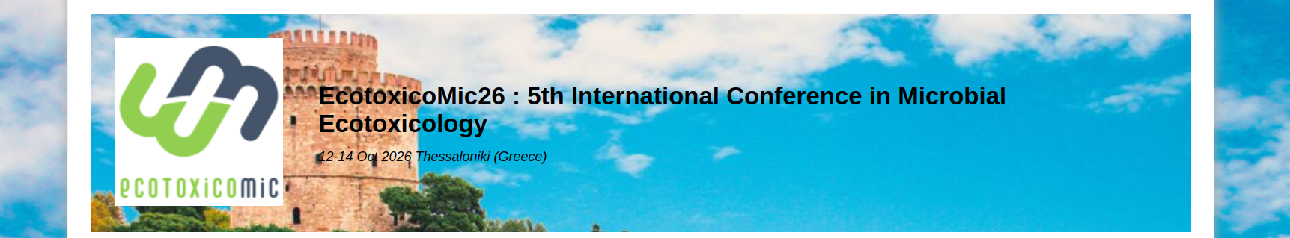
EcotoxicoMic grants – application form

Checklist
□ abstract submitted to Ecotoxicomic 2026 as presenting author
□ CV (max 3 pages)
□ motivation letter (max 1 page)
□ for students and researchers in non-permanent position: approval letter from your supervisor
□ the present application form completed, including a budget estimation

General information
Name:
Family Name:
Email:

Place of employment:
Position held:
Highest academic degree obtained:
Year of obtaining your highest academic degree:

Submission to Ecotoxicomic 2026
Title of abstract submitted to Ecotoxicomic 2026:

Type of presentation:

Reminder: The grant selection committee is independent from the abstract selection committee. Receiving a grant does not guarantee acceptance of a presentation, and vice versa.

Budget estimation
Please provide an estimation of your budget for your participation at the conference including conference fee registration, travel and accommodation expenses, and other if pertinent. Indicate whether you have applied for other financial support.

Grant amount requested (€):
Do you apply for partial or full financial support ?

Did you receive a grant to participate to an international conference since 2021 ?
If Yes, please indicate who awarded the grant(s) and for which conference(s):

